Ein Bild, das Schrift, Symbol, Screenshot, Grafiken enthält.

**How does the release of ChatGPT affect firms and the risks they face?**

BAN432, fall 2023 – Final Project

Applied Textual Data Analysis for Business and Finance

NORWEGIAN SCHOOL OF ECONOMICS

Candidate No.: 106

Candidate No.: 105

Bergen, 20.12.2023

**Content**

List of Figures IV

1 Introduction 1

2 Data preparation and cleaning 2

3 Which Industries Are Affected By The Release Of ChatGPT? 3

4 What Are The Risks Firms Face Regarding AI? 11

5 Conclusion 18

6 Limitations 19

Appendix 21

List of Figures

Figure 1: Mentions of ChatGPT per GICS sector 5

Figure 2: Mentions of ChatGPT per GICS sector (weighted) 6

Figure 3: Mentions of ChatGPT per company 7

Figure 4: percentage of companies per sector mentioning ChatGPT 8

Figure 5: Percentage of companies per sector mentioning ChatGPT (before and afer release) 8

Figure 6: Wordcloud of KWIC for ChatGPT 9

Figure 7: Most common negative and positive words from KWIC of ChatGPT 10

Figure 8: Topics from 2-stage sentiment analysis 13

Introduction

In recent years, artificial intelligence (AI) has gained a lot of intention as it has undergone remarkable advancements, establishing itself as a pivotal technology across various industries. The rapid evolution of AI positions it as a transformative force across diverse societal sectors, including healthcare, finance, transportation, and other industries. Its widespread availability and potential for significant impact has prompted industries to explore and leverage AI's benefits in their operations.

In particular, the release of ChatGPT by OpenAI in 2022 has notably revolutionized company related work activities and has introduced new dimensions of efficiency and innovation. Examples include financial institutions that can leverage ChatGPT's capabilities to provide customers with automated, personalized investment advice or companies in the healthcare sector, where providers can utilize ChatGPT's advanced predictive analytics to offer more intelligent patient care solutions. These examples highlight ChatGPT's and more broadly AI´s broad applicability and opportunities across various industries.

However, alongside the numerous advantages offered by ChatGPT and AI technologies, companies must also navigate a range of inherent AI related risks. One significant concern could be financial risks which arise from high development and integration costs or even more pronounced risks regarding existing products and services being displaced by AI alternatives, which could lead to failures of companies that are not able to adapt. Furthermore, concerns about privacy and data security are being widely discussed in the context of AI.

This article seeks to answer two critical aspects, considering the dual nature of AI's potential both positive and negative impacts: First, it identifies the industries that are affected by the release of ChatGPT. Second, it explores the potential risks firms face regarding AI. To analyze these essential aspects, over 7.000 earnings calls from listed American companies between 2021 and 2023 serve as the primary data source. We conduct a textual analysis employing a combination of quantitative and qualitative methods.

Data preparation and cleaning

Because the data is retrieved from websites and originates from an oral format, it contains noise, e.g. in the form of HTML tags or frequent use of common words. We perform several data preparation and cleaning steps to minimize possible noise channels, starting with general and proceeding with more case-specific cleaning steps.

Retrieval of Text from HTML Source

The data is given in HTML format. We thus must extract the plain text from the HTML source and remove HTML tags. Excess white spaces, punctuation and numbers are also removed. Moreover, all characters in the corpus are transformed to lower-case characters and abbreviations (Sr. à senior) as well as contractions (can´t à cannot) are changed to their extended forms.

Remove Stopwords

Next, we decide to remove stopwords, which are frequently used words of the English language, and which occur frequently across all documents in the corpus, but don´t have any significant meaning for our analysis. Common stopwords are for example “the”, “and”, “it”. Generally, there are different ways to remove stopwords. We use a predefined list of stopwords in the stopwords R-package to remove all words from our corpus that occur in that list. To remove further uninformative words, we define a set of custom stopwords as defined in Appendix D that appear frequently in earnings calls, and remove them as well.

Remove Company Names

Another source of possible “noisy” words are the respective company names of a specific earnings call, which transport no relevant information regarding answering the two main research questions and therefore are removed from the data. We download a list of companies from Thomas Reuters Eikon and match them with the stock symbols in our earnings calls data. We remove all words contained in company names, e.g., when a company is called “Microsoft Corp”, we remove “Microsoft” and “Corp”.

Limit Word Length and Lemmatization

Next, we decide to only keep words that have a minimum word length of three letters and maximum word length of 20 letters. We further lemmatize all words so it becomes easier to process and analyze large volumes of text and to perform tasks like keyword extraction and sentiment analysis.

Note that for our approach to answer RQ 2, we use different cleaning steps in some steps. Whenever this is the case, it is indicated in the text as well as in the coding file of Appendix A.

Which Industries Are Affected By The Release Of ChatGPT?

The first main question to be answered in this paper is which industries are affected by the release of ChatGPT. To address this question, we conduct the following two general steps: (1) we identify the companies and their industry classification based on the provided earning calls documents and (2) if and how the different industries are affected by the release of ChatGPT.

Identification of industries

The identification of the industries from the earnings calls transcripts is not trivial. The data is given as one large list per earnings call, each including several elements that contain information about stock symbols, linkage to other items, authors, industries and much more. In the first step, we inspect a few earnings calls documents manually and realize that the elements in the “included”-list as well as the $themes-lists in the $data-list contain useful information about company and industry. We merge both information in the $included-list and from the $themes-lists and identify around 4600 earnings calls that contain industry information. However, we are unable to classify the remaining 3000 earnings calls with this approach. We decide that dropping 3000 earnings calls from our analysis is not satisfactory and thus download a list of companies classified by the GICS industry classification and join this list via the stock symbol. The stock symbol is given in the $included-element [[2]] in our data. With this approach we are able to classify 7310 of 7643 earnings calls, which in our opinion is a satisfactory number that we can continue to work with. Having a proper industry classification is essential to answer the first question.

The GICS standard classifies companies in 3 levels: 11 sectors, 25 industry groups, 74 industries, and 163 sub-industries. We conclude that the best classification level for our dataset is the sector-level. Thus, the rest of this analysis is conducted over the eleven sectors “Materials”, “Health Care”, “Industrials”, “Consumer Discretionary”, “Consumer Staples”, “Energy”, “Information Technology”, “Real Estate”, “Financials”, “Communication Services”, and “Utilities”. Earnings calls that we cannot match to these sectors are excluded from further analysis.

Which industries are affected by the release of ChatGPT?

To answer this question, we first transform our data frame containing 7.310 earnings calls to a Document-Term-Matrix (DTM). This transformation is an important step as it transforms textual data into a structured, numerical format, where each row represents a document, and each column corresponds to a unique token (here: word). This transformation is crucial for applying quantitative methods to text, enabling tasks like frequency analysis and document comparison. By presenting text data in a matrix format, a DTM facilitates more effective and efficient analysis of large text corpora.

Our approach is structured in 3 main steps:

1. Define keywords around ChatGPT.
2. Calculate keyword frequencies per sector.
3. Normalize keyword frequencies per sector.
4. Analyzing keywords in context (KWIC)

Our main assumption with this approach is that companies and sectors that talk frequently about ChatGPT in their earnings calls are affected by its release.

Step 1: Define Keyword List

Since the first question specifically asks for ChatGPT, which is one of many AI tools, we decide on a narrow list of keywords that are directly linked to ChatGPT. Our final list of keywords contains “chatgpt”, “gpt”, and “openai”. Note that we refrain from using for example “AI” or “artificial intelligence” or other related terms in this list, since both terms are much broader and do not necessarily correspond to an impact of ChatGPT, when mentioned. We intentionally choose very few keywords and very narrow keywords, to be sure that our findings indicate an effect of ChatGPT specifically.

Step 2: Calculate Keyword Frequency

Figure 1 shows the keyword frequency per sector, as a sum over the frequencies of each keyword.

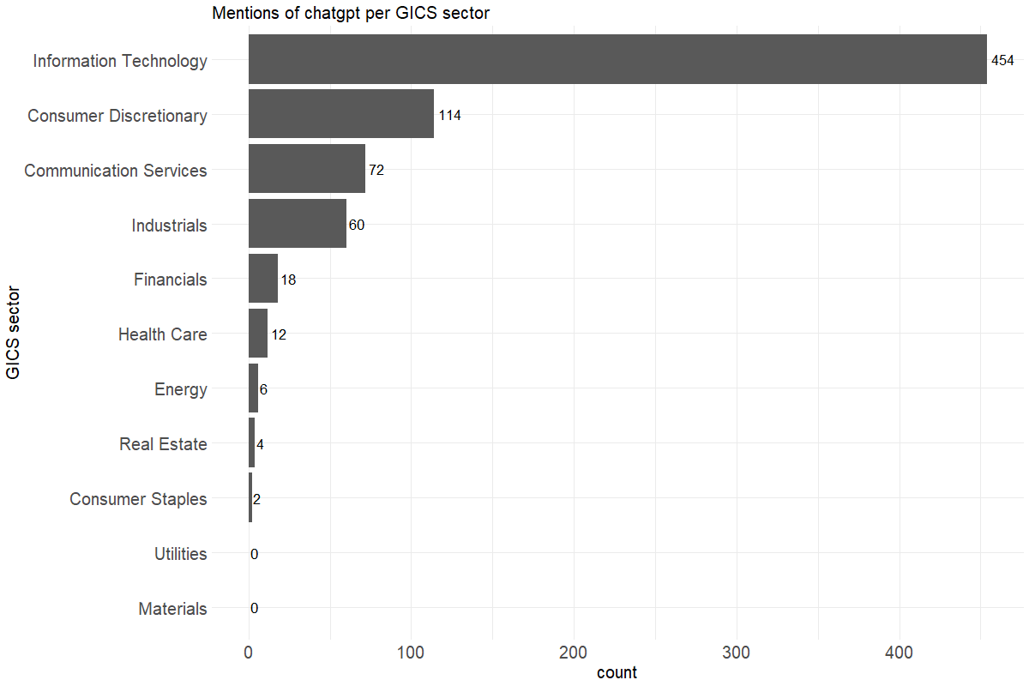

Figure 1: Mentions of ChatGPT per GICS sector

We can see that the Information Technology sector has by far the most keyword mentions. Consumer Discretionary, Industrials, Health Care, Financials, and Communication Services mention our keywords frequently as well, but, Energy, Consumer Staples, and Real Estate barely do so. Notably companies in the Utilities and Materials sectors seem to not talk about ChatGPT at all. At first sight, this makes sense from basic human intuition, however, by just taking the sum of all mentions as a measure of impact, we neglect that we do not have the same number of earnings calls per sector. Consequently, in the next step, we normalize the keyword frequencies.

Step 3: Normalizing Keyword Frequencies

We take the simple normalization approach by dividing the number of mentions per sector by the number of earnings calls in our data for each sector multiplied with 100. Figure 2 shows the normalized term frequencies.

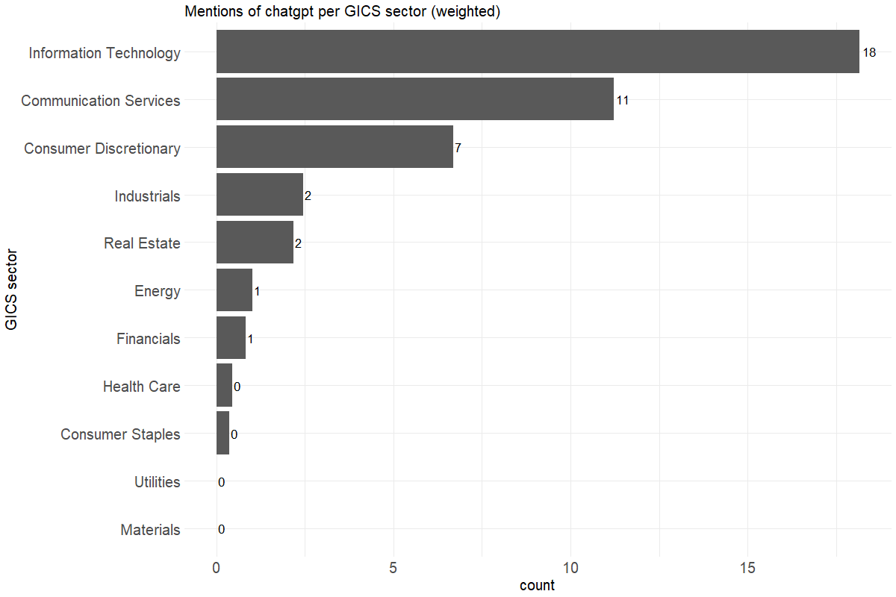

Figure 2: Mentions of ChatGPT per GICS sector (weighted)

We still observe that Information Technology has the most weighted mentions across all sectors. However, the difference is much smaller, which is due to the fact that we have proportionally more earnings calls from the Information Technology sector.

Although the weighted frequencies eliminate one concern, we still neglect the number of companies per sector. Furthermore, if one company of earnings call contains significantly more keyword mentions, this represents a bias in our analysis since we cannot infer an effect on the sector if only one company accounts for all keyword mentions. Figure 3 displays the mentions of keywords per company.

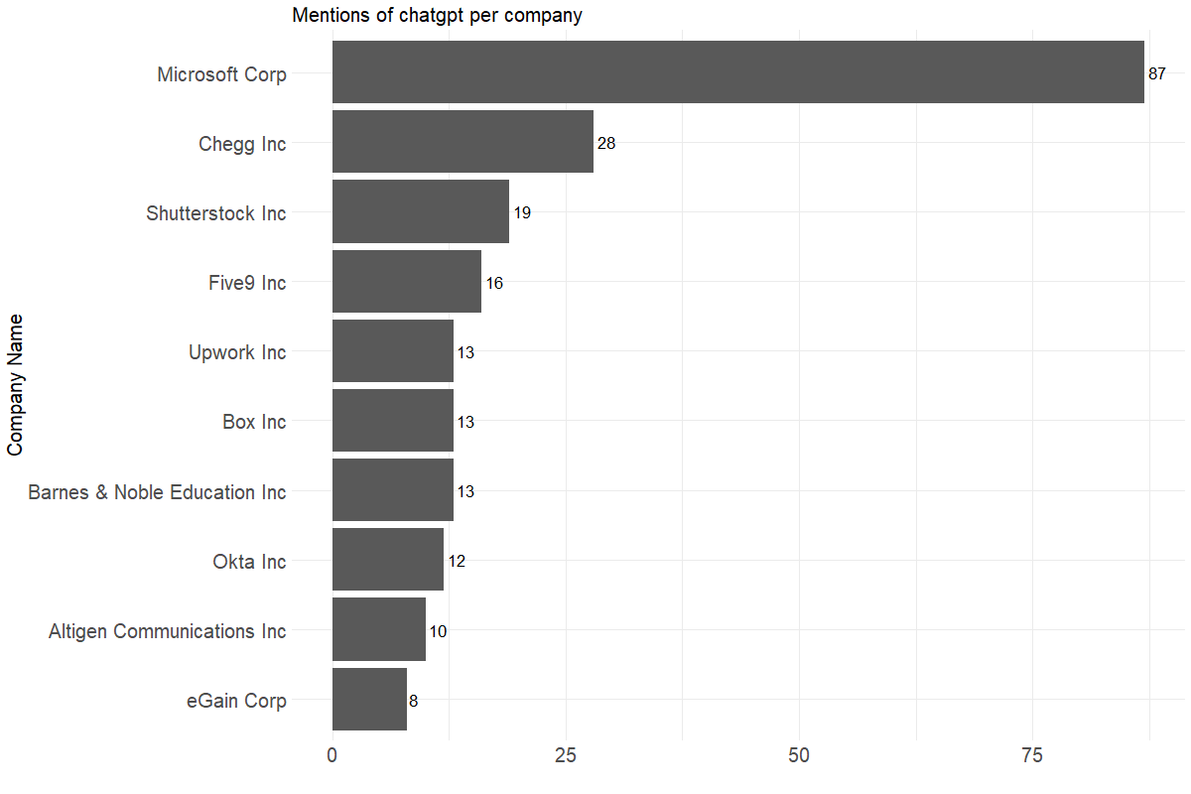

Figure 3: Mentions of ChatGPT per company

Notably, some companies mention keywords comparably often, e.g. Microsoft references our keywords 87 times across all its earnings calls. However, frequent mentions by a single company do not necessarily indicate an industry-wide impact from the introduction of ChatGPT. Therefore, we adjust the keyword frequencies for our final measure of impact.

We calculate the number of companies that mention keywords per sector at least once in one of their earnings calls and divide it by the total number of companies in that sector. By focusing on the number of companies mentioning the keywords rather than the frequency of mentions, the analysis reduces the bias that might be introduced by a few companies discussing a topic very frequently. It ensures that the findings reflect a broader sector perspective, rather than an over-representation of a few vocal players. Moreover, this method measures the level of engagement or interest in ChatGPT within a sector. If a high percentage of companies mention a particular keyword, it suggests that the topic is widely relevant or important in that sector and therefore this sector could be in conclusion highly affected by the introduction of ChatGPT. Figure 4 shows the percentage of companies within each sector, that mention ChatGPT-related keywords.

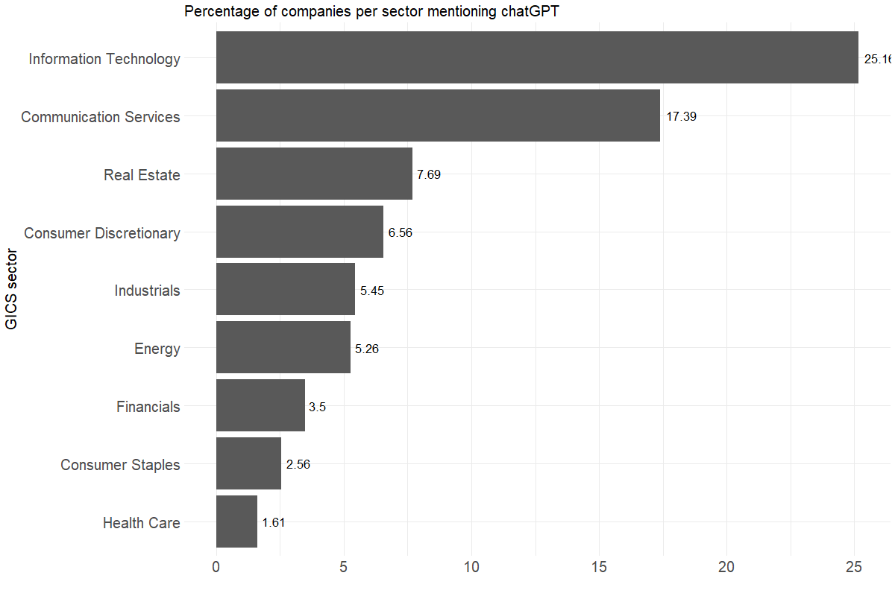

Figure 4: percentage of companies per sector mentioning ChatGPT

Interestingly, the difference between sectors seems to diminish with this approach. 25.16% of Information Technology companies and 17.39% of Communication Services companies mention ChatGPT, whereas only 1.61% of Health Care companies talk about ChatGPT. For all other sectors, below 10% of companies mention the keywords.

Furthermore, Figure 5 splits the mentions in before and after the release of ChatGPT (November 30th, 2022).

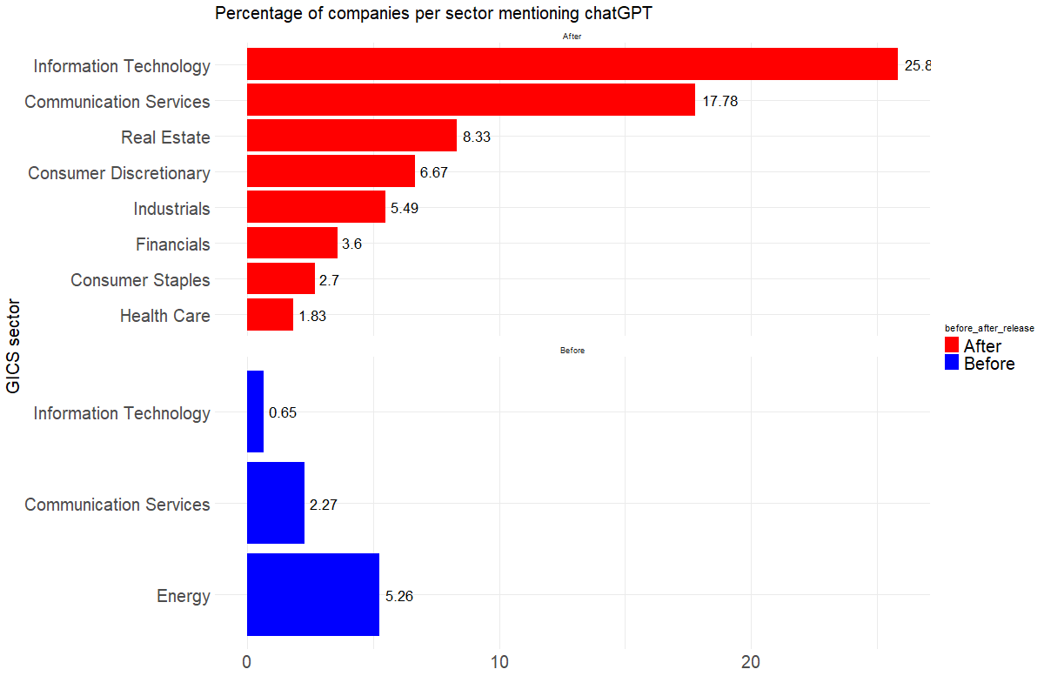

Figure 5: Percentage of companies per sector mentioning ChatGPT (before and afer release)

We can clearly see that most of the keyword mentions are after the release, as would be expected. However, in the Energy Sector there seem to be mentions only before the release, which is surprising. After inspecting the mentions in the Energy sector, these mentions are of the keyword “gpt”, which in energy context can correspond to a different abbreviation other than belonging to ChatGPT.

Thus, the findings indicate that our keyword mentions are due to the release of ChatGPT.

Step 4: Analyzing Surrounding Words

To further strengthen our claim, that mentions of the keywords indicate an impact on the sector, we look at surrounding words of our keywords. To do this, we make use of the KWIC-Function, which lets us analyze n words before and n words after the respective keywords. Please note that we use the full content before the application of the cleaning steps as described earlier. After small cleaning steps of the text before and after our keywords, we create the wordcloud in Figure 6 for the keywords in context with a window of 30.

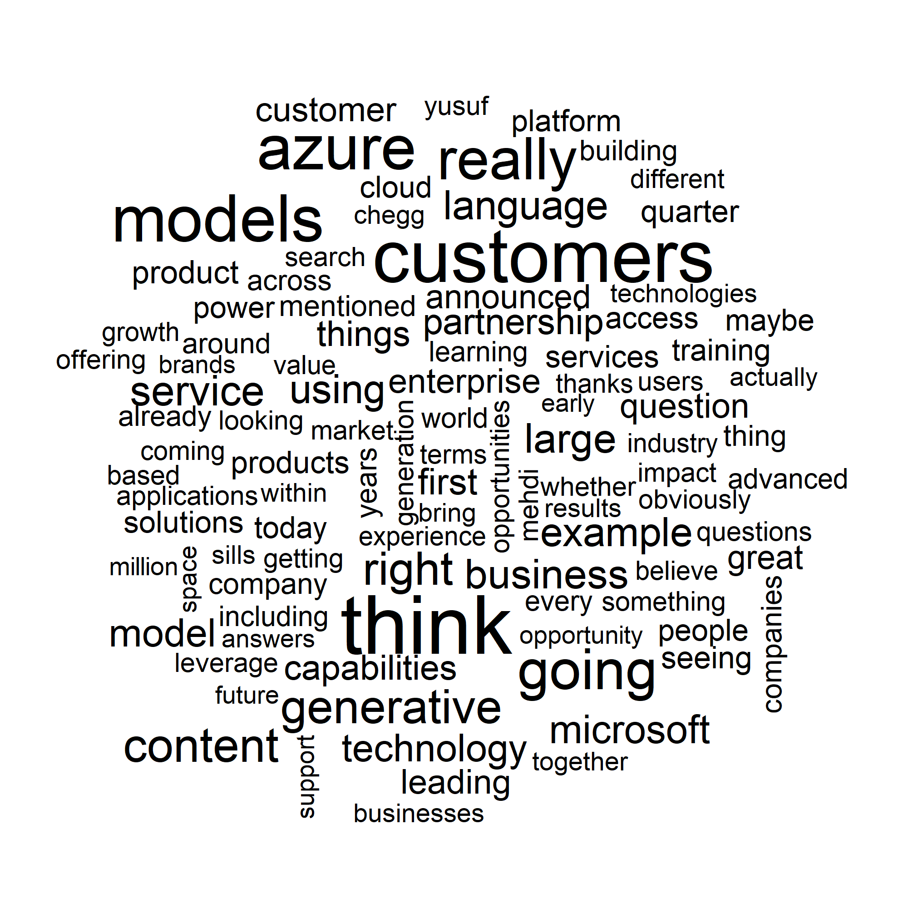

Figure 6: Wordcloud of KWIC for ChatGPT

To say something about the impact, we hope to identify words in the surrounding of our keywords, that let us infer that they are talking about certain effects of ChatGPT in the earnings calls. Indeed, looking at the wordcloud in Figure 6, there are many of such words present: For example, customers, product, capabilities, impact, application, partnership, partners, opportunities, productivity, value, leverage, leading, or growth all allow for this interpretation. Please note that this interpretation of the wordcloud is of a very qualitative nature, however, clearly shows a tendency when looked at with human intuition. Furthermore, it is important to note that the wordcloud contains the company-bias as described earlier, indicated by the very frequent mentions of “microsoft” and “azure”.

We then take a quick look at the sentiment of the words surrounding the keywords. We assume that in general, if there is an effect, we would observe many words that inherit positive or negative meaning. Figure 7 shows the most frequent positive and negative words from the KWIC table, as defined by the Loughran-McDonald (LM) dictionary.

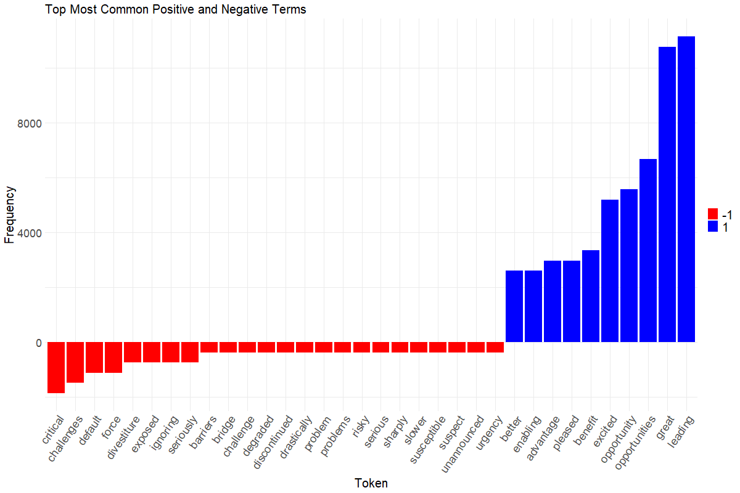

Figure 7: Most common negative and positive words from KWIC of ChatGPT

Positive words are clearly more frequent, which would lead to the interpretation that the tone around “ChatGPT” is in general very positive in the earnings calls. This could indicate, that based on our data sample, managers see “ChatGPT” more as an opportunity, rather than a risk. This is an important observation that will influence the second RQ.

To conclude, our approach results in the following answer to the research question. The sectors that are most affected by the release of ChatGPT are Information Technology and Communication Services. Not affected at all as determined by no mentions of ChatGPT are the Energy Sector and the Materials Sector. However, all other sectors seem to be affected to some extent but talk significantly less about ChatGPT compared to Information Technology and Communication Services. KWIC supports this interpretation, suggesting a mainly positive attitude towards ChatGPT. We will conclude with limitations at the end of this paper.

What Are The Risks Firms Face Regarding AI?

The second main question asks for specific risks regarding “AI”. We employ a variety of textual analysis techniques to pinpoint risks discussed in the earnings calls in relation to "AI”. In the end, we use a mix of quantitative and qualitative text analyses tools in a creative approach to identify 4 key risk areas. It is important to point out that we land on this approach through a long process of employing and combining different methods for text mining. We thus break down our thought process in six steps and explain in detail our reasoning behind each step.

1. Definition of AI-related keywords
2. Extraction of earnings calls mentioning AI-related keywords
3. Sentiment analysis by sentence
4. Clustering of above sentences by key negative terms according to LM dictionary
5. Topic modeling of the resulting corpus
6. Qualitative analysis and interpretation of negative sentences

It is important to note that our approach is built on the assumption that risks are usually discussed in a negative sentiment. Furthermore, we rely heavily on the LM dictionary to adequately capture the essence of negative topics or risks in earnings calls.

Step 1: Definition of AI-related keywords

Unlike the first RQ, this task asks about risks firms face regarding AI in general, and not just regarding ChatGPT specifically. We thus decide to extend our keyword list for RQ 2. We define the follwing keywords: "gpt","chatgpt", "aiaiai", "openai", "openais", "artificial", "chatbot", "intelligence". To easier set the word lengths bounds in the DTM, we replace “ai” with “aiaiai” in every document. Furthermore, we intentionally decide to keep the keyword list short and refrain from including words like “natural”, “language”, “processing”, since these terms are also frequently used outside the context of AI and would thus increase the noise in our analysis. Moreover, we assume that AI as a widely used buzzword will capture the most of AI-related content in all earnings calls and that additional keywords do not add any value to the analysis.

Step 2: Extraction of earnings calls mentioning AI-related keywords

To decrease the corpus size and only focus on the important earnings calls, we first filter the DTM to documents that contain AI-related keywords and extract the respective document IDs from the DTM. This decreases the number of earnings calls from 7.310 to 272. Furthermore, to continue with the next step, we pull all uncleaned documents that contain our keywords, since we need sentences to run the sentiment analysis by sentence.

Step 3: Sentiment analysis by sentence

In the first sentiment analysis, the goal is to capture only negative sentences, that contain AI-related keywords. We first make use of the sentimentr-package to get all sentences and compute their sentiment. From the 272 earnings calls transcripts containing AI terms, we extract in total 115.704 sentences. However, we do not want to analyze all sentences, but only the ones that contain AI terms. Consequently, we filter all sentences to the ones that match our keywords, which results in 4.969 sentences. This will be the final corpus that we conduct our analysis on. Results from the sentimentr-analysis reveal 346 sentences with a negative sentiment, 568 sentences with an uncertain sentiment, and 4.055 sentences with a positive sentiment. Taking a small sample of negative, positive, and uncertain sentences, and reading through the, however, reveals that we cannot be certain about the classification of the sentimentr-algorithm. We can find many positive sentences in the ones that are classified as negative and vice versa. We thus decide to proceed with our analysis of risk extraction in two different ways. First, we conduct another iteration of sentiment analysis in combination with topic modelling. Second, we conduct a qualitative interpretation and try to cluster the 346 negative sentences into risks. Both steps are outlined in the following.

Step 4: Clustering of above sentences by key negative terms according to LM dictionary

As described above, we observe sentences that we could infer risks from in both negative and positive sentences. In this iteration of sentiment analysis, we try to capture more “negativity” (and thus risk-related sentences), by making use of the widely used LM-Dictionary. Specifically, we take all 4.969 AI-related sentences and construct every sentence with its trigrams. Next, we filter the resulting list of trigram-tokens to contain at least one negative word from the LM-Dictionary and at least one of the AI-related keywords. By this, we ensure that the negative words appear in the immediate surrounding of the keywords. Furthermore, we try to exclude unnecessary negative words with this approach, which will be important for the next step. Taking the unique negative words from the LM dictionary contained in the filtered trigrams results in 42 negative words. Lastly, we cluster all 4.969 AI-sentences around these 42 negative terms. One term now corresponds to one “document-id” and every sentence is assigned to every negative word that is contained in the respective sentence. The result is a 42-document corpus, which is supposed to capture different domains of negativity from AI-sentences. We proceed with step 5.

Step 5: Topic modelling of the resulting corpus

Conducting LDA topic modelling on the resulting corpus, we hope to identify risks from the resulting topics. We choose to estimate k = 12 topics, which are displayed in the following table. Note that one must employ human intuition and interpretation to specifically name a certain topic from the terms in this topic. Consequently, the column “Topic” is inferred using basic human reasoning.

|  |  |
| --- | --- |
| **Topic** | **Top 8 Terms (decreasing log of probability)** |
| Data & Security Threat | concerns, cost, data, health, deliver, might, understand, today |
| No risk inferred | well, around, content, able, create, using, terms, things |
| Data & Security Threat | intelligence, time, safety, breast, sales, mission, without, designed |
| No risk inferred | problems, going, becomes, business, solve, within, already, problem |
| Strategic & Market Risks | disruptive, will, company, platform, products, just, intelligence, well |
| Data & Security Threat | data, threat, security, intelligence, customers, look, management, sort |
| No risk inferred | think, generative, across, cloud, going, system, pervasive, applications |
| Market Demand Risk | artificial, help, force, customer, will, customers, platform, market |
| No risk inferred | critical, important, capabilities, data, generative, edge, automation, design |
| Market Demand Risk | customers, solutions, advantage, need, thing, solution, potential, work |
| No risk inferred | latest, technology, also, later, learning, machine, capabilities, unique |
| Financial Risks | million, segment, losses, quarter, reporting, ebitda, adjusted, related |

Figure 8: Topics from 2-stage sentiment analysis

Furthermore, note that we are not able to infer risks through interpretation for all topics (“No risk inferred”). We proceed with Step 6.

Step 6: Qualitative analysis and interpretation of negative sentences

To obtain a more extensive understanding of the risks associated with AI mentioned by the companies in our sample, we conduct a qualitative review of the 346 negative sentences in this step. Based on our findings of the performed topic modeling, we first analyze and formulate three topics, namely “1. Financial and economic risks” and “2. Privacy and security risks” and “3. AI Adaption risks and Market demand Risk”. After screening the remaining sentences, we were able to formulate another topic, “4. Strategic Risks”.

The sentences are extracted from Appendix F and the ID corresponds to the position of the sentence in the negative_sentences-vector. We quote a few examples for all risk categories.

1. Financial and economic risks

The analysis of earnings call transcripts highlights significant financial and economic risks associated with AI. Sentences 5, 26, 27, 242 for example collectively point towards tangible financial losses in AI segments, reflecting the high investment expenditure and potentially risk in relation to AI technology, if the company is not able to generate the expected return from its prior investments. More specific the reported losses in AI divisions amplifies the narrative of financial risk, emphasizing the need for cautious and strategic financial planning in the adoption and implementation of AI technologies. Example sentences for Financial and economic risks:

*[27] "$24.9 million of pre-tax losses related to our ai reporting segment."*

*[242] "our adjusted ebitda guidance for 2023, excludes anticipated adjusted ebitda losses of approximately $10 million from our ai division, which is deep health aidence and quantib."*

2. Privacy and security risks

In the context of corporate management, the integration of AI technologies presents distinct privacy and security risks that companies must navigate. Sentence 14 from the earnings call transcripts reveals a critical risk where AI could be exploited by adversaries to manipulate or compromise security systems, posing a direct threat to corporate security infrastructure. In the same vein sentence 228 mentions the increased likelihood of cyber threats that accompany the adoption of AI and machine learning technologies. Additionally, the threat to data privacy, as highlighted in sentence 79, is a paramount concern for companies dealing with sensitive customer and business information. In conclusion this could lead to a loss of sensible company or customer related data, which ultimately leads to potential reputational and business risks, when e.g., data about a secret production process or customer specific private data is stolen.

*[14] "so the use of ai, specifically by the adversary to try to deceive security systems."*

*[79] "ai could make your data more valuable, but it's also a threat to data privacy."*

*[228] "number two, as ai/ml gets picked up, there'll be bigger cyber risks."*

3. AI Adaption risks and market demand risks

On one side, there's expanding demand for AI products in the market, as highlighted among others in sentences 108, 158, 185 indicating a significant opportunity for companies in the AI space. However, there are significant risks associated with this opportunity. Sentence 1 describes that companies currently lacking in AI capabilities might face severe deficiencies in the future, hindering their ability to leverage these market opportunities effectively. Additionally sentence 340 mentions the required “[…] substantial amount of work […]” in relation to AI implementation and product development. The potential future gap in AI capabilities in connection with the required work presents a significant strategic risk, impacting a company's competitive positioning and growth potential in an AI-driven market.

In addition, sentence 18 brings to light another pivotal risk - the challenge in recruiting world-class AI engineers and scientists. This talent shortage poses a substantial barrier to AI development and innovation, thereby impacting a company's ability to respond to the high market demand for AI solutions. It can also indicate the risk of being left behind by other industry players, as they can secure business related advantages through in-house AI development and implementation.

*[1] "but there are others who lacked in this department and need to work on that because in the ai future, this would be a serious deficiency."*

*[108] "whether that’s a precursor to expectations on ai or machine learning or not, it is an area that we’ve seen strong demand."*

*[158] "since you asked about client demand, i'd say we're really seeing explosive growth in the area of ai itself."*

*[185] "and so the demand for using mongodb to build and run these ai apps is very high."*

*[340] "and i think everybody is trying to figure out their strategy of how do they bring generative ai to their enterprise use cases, which is going to -- which requires a substantial amount of work in kind of the abstraction layer between ai models, customer data and cloud infrastructure, and that's exactly what we're building out."*

*[18] "there were just some of the world’s best ai engineers and scientists that were willing to join a startup, but they were not willing to join a large sort of relatively established company like tesla."*

4. Strategic risks

In the context of the rapid development and extensive deployment of AI, companies face unique strategic risks. A notable risk could result from the in sentence 288 mentioned overall euphoria about AI or the mentioned extensive use of AI in business process in sentence 129. This euphoria und extensive use could lead to an over-reliance and overestimating of AI and its abilities, especially in the light of potential problems with the accuracy and reliability or bias of AI models and ai generated data, as mentioned in sentences 2,17, and 39, which could lead to strategic missteps and operational failures, eroding customer trust and affecting market performance. In the same sense sentence 22 mentions Managers using AI “[…] as an excuse to get leaner”, which poses a strategic risk for companies, primarily due to the potential for short-sighted workforce reductions. This approach, focusing on immediate cost savings, risks losing essential human expertise and innovation potential, crucial for long-term success. It also has a significant impact on employee morale and trust, potentially harming the company's reputation and its ability to attract and retain top talent.

*[288] "look, long-term, i think, we are in the early euphoria of ai right now and i don’t want to kind of try to prognosticate what ai will mean, let alone what it will mean sort of ethically and more -- metaphysically and all of those things, but what we know for sure is it requires a lot of interconnect today."*

*[129] "on the social side, in the business world, our ai is removing bias and increasing diversity in the recruitment and hiring process across all commercial segments of our economy."*

*[2] "regurgitating bad data, bad opinions or fake news, where ai generated deep bases, for example, will be a problem that all generative ai will likely be dealing with for decades to come."*

*[17] "we don’t want people to use the ai to cause harm, self-harm and otherwise sort of bias against people."*

*[39] "otherwise, your ai is making trend predictions and other predictions based on what i call crappy data."*

*[22] "over the short-term, i think most ceos are using ai as an excuse to get leaner."*

In conclusion the second main question “What are the risks firms face regarding AI?” can be answered in the following way: (1) companies in general face risks regarding AI and (2) that these risks can be categorized based on our data sample of more than 7,000 earnings calls into four main topics, namely “financial and economic risks”, “privacy and security risks”, “AI adaption risks and market demand risk” and “strategic risks”. These identified risks are the result of a variety of different applied quantitative and qualitative textual analysis methods, which build on each other.

Conclusion

This study sought to answer two pivotal questions: firstly, which industries are impacted by the release of ChatGPT, and secondly, what potential risks businesses face in regard to AI. Our analysis utilized a substantial dataset comprising over 7,000 earnings calls from U.S. listed companies, from the years 2021 to 2023.

To effectively respond to these questions, we conduct a multiple-step preparation and cleaning process, as detailed in Chapter 2. This foundational step, which included crucial tasks such as lemmatization and the elimination of non-informative words, was essential for enabling a nuanced analysis.

Addressing the first question involved a four-step methodology, with the core components being: (1) formulation of a list of related keywords, (2) constructing a frequency and (3) normalized frequency distribution across sectors, and (4) analyzing contextual usage of these keywords (KWIC). We implicitly hypothesized that sectors where executives frequently mention ChatGPT are likely those most influenced by its release. The analysis reveals that the Information Technology and Communication Services sectors are the most impacted by the release of ChatGPT. In contrast, the Energy and Materials sectors appear to be unaffected, as demonstrated by the absence of ChatGPT mentions in their discourse. Other sectors show varying degrees of influence, with discussions about ChatGPT present but considerably less frequent compared to the Information Technology and Communication Services sectors. The KWIC analysis further corroborates these findings, indicating a predominantly positive perception of ChatGPT across the sectors where it is mentioned.

The second question was explored using a combination of quantitative and qualitative methods, encompassing six distinct steps. Our approach started with extracting sentences containing predefined keywords related to AI. Subsequently, we conducted sentiment analysis on these sentences. The third step involved clustering sentences around negative connotations using the LM Dictionary and applying LDA Topic Modeling to these clusters. This process aimed to identify potential risks associated with AI. Although we are able to identify four risk topics related to AI, we further performed a qualitative analysis on negative AI sentences. This paper concludes that AI introduces a range of risks that can be classified into four main areas based on an extensive review of over 7,000 earnings calls. The categories are: (1) Financial and Economic Risks, related to the fiscal impact of high AI related investments with unknown return; (2) Privacy and Security Risks, focusing on data protection and security concerns; (3) AI Adoption and Market Demand Risks, examining challenges in adopting AI and responding to market changes; and (4) Strategic Risks, dealing with the potential risk of overreliance on AI. The integration of topic modeling outcomes and qualitative analysis resulted in the identification of four primary risk domains and their sub-risks. A significant achievement of this methodology was condensing the original corpus of over 7,000 documents and over 2 million sentences to a focused collection of less than 400 sentences, which was instrumental in pinpointing AI-related risks for businesses through text mining techniques.

Limitations

Although we are able to answer both research questions successfully with a textual analysis approach, there are some limitations to both approaches.

In the identification of affected industries, we rely heavily on the appearance of only three keywords. In general, none of the keywords is mentioned very frequently in any of the sectors, which can be criticized when we infer information about an impact from this frequency. Furthermore, the KWIC analysis we used displays frequencies of single words only and cannot capture negations of these words. Another approach that could have been used to assess the importance of the keywords to companies or sectors mentioning them, is a term-frequency-inverse-document-frequency analysis (TF-IDF). A high TF-IDF score indicates high relative importance of a word to a specific document. Further analysis should include a TF-IDF score evaluation for keywords. Thirdly, we do not conduct statistical tests to evaluate whether the differences between the percentages of companies mentioning ChatGPT is statistically significant or whether one sector differentiates significantly from all other sectors.

In the extraction of risks from the earnings calls, we assume that risks are associated with negative words from the LM dictionary. We do not make use of any other dictionaries, which could potentially yield different results. Furthermore, we base our judgement only on sentences that contain AI related words. However, surrounding sentences may also contain important explanations or definitions of risks regarding AI. Additionally, negations can reverse the meaning of the negative words. Moreover, the nature of earnings calls transcripts depicts the division into executive presentation and Q&A-Session or executives speaking and analysts speaking. Both sections could potentially contain different sentiments and risks. By analyzing both sections together, one could argue that the overall sentiment may be biased. We split the dataset into Q&A-Session and executive presentation but were not able to conduct differentiated analysis on both.

Appendix

1. Main .R Coding File BAN432_FinalProject.R
2. Functions .R Coding File BAN432_FinalProject_Functions.R
3. Data .R Coding File BAN432_FinalProject_AdditionalData.R
4. Custom Stopwords stopwords_extended.xlsx
5. GICS Classification gics_classification.xlsx
6. Negative Sentences File negative_sentences.Rdata